**IFT 466 Advanced Computer Networks**

**Lab 21  
Spanning Tree Protocol (STP) – Beyond an introduction**

After you complete each step, put a ‘√’ or ‘x’ in the completed box

**Reminder**STP is a layer 2 protocol that runs on bridges & switches. It builds a **loop-free** topology for Ethernet networks. The basic function of STP is to prevent bridge & switch loops and the broadcast signal that results from them. STP also allows a network design to include backup links to provide a fault tolerance system, if any active outgoing port links fail.

**Objectives**

Understand the basic concept of what the Spanning Tree Protocol (STP) does.

1. Setup the following topology in packet tracker

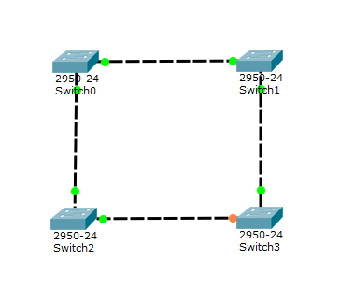



✓

1. As you can see from the topology you just created in packet tracer, STP has shut down the port access to one of the switches ports due to redundancy, to eliminate switching loops, and to prevent broadcast storms.

To understand STP, you need to:

* Identify the root bridge
  + STP will choose a root bridge by determining the bridge with the lowest bridge ID. The bridge with the lowest priority will override and become the root bridge. If multiple bridges have the same priority, the bridge with smallest MAC address will become the root bridge.
* Identify the root port for each non-rooted bridge
  + Everyone non-rooted bridge will choose to use the port with the lowest cost to the root bridge. The port with the lowest cost will be made the root port. Root ports will allow for forwarding of frames access the network.

Once a switch has identified its root bridge and any non-rooted ports, all other ports are put in a **blocked state.** No traffic is sent out blocked ports and traffic is not received or forwarded out any other port.

1. Now open the cli on each switch and run the command show spanning-tree active to identify which switch has been made the root bridge.

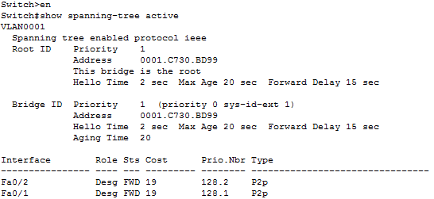

In this topology, Switch 0 has been made the root bridge by default.****

✓

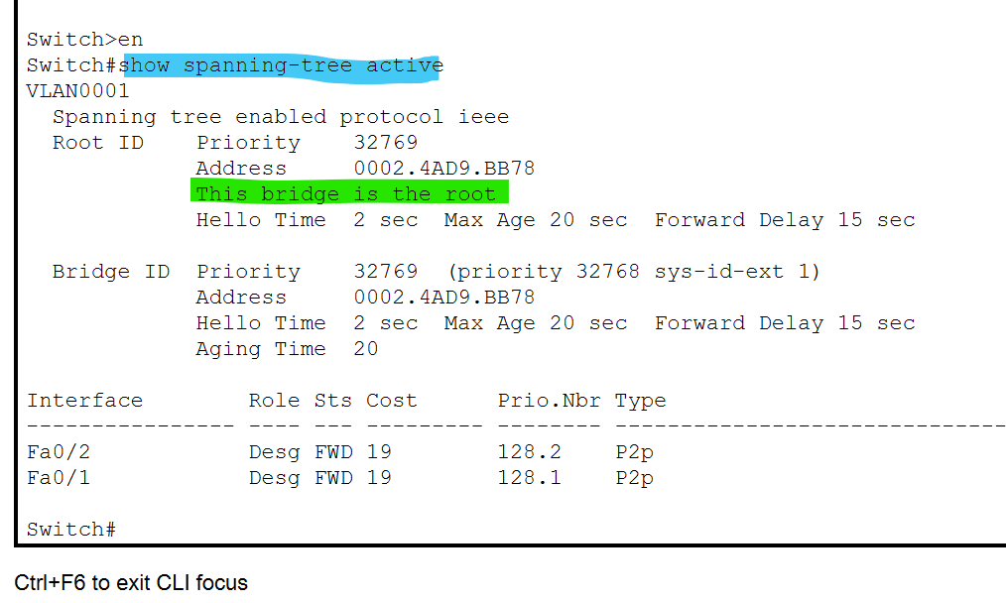

1. What would happen if you disabled STP between all the switches?

Let’s do it.

Type the following command into every Switch’s CLI (you will need to be in configurations mode):   
 **no spanning-tree vlan 1**

Your topology should now look like this:

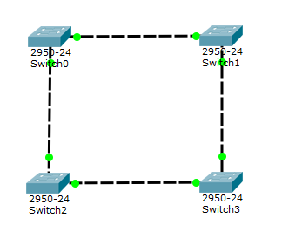

All switches are broadcasting on all forwarding ports.



✓

If a switch wanted to send a frame out, it does not know which port interface to use. It will broadcast the frame out on all interfaces, making it so the source address of the frame change. Since this broadcast will go out through all ports, the outgoing broadcast frames will have different source addresses → **Broadcast Storm**.

In our example, our network is small, but in a much larger network this process will keep on going till the network becomes congested with multiple duplicate frame destinations, thus reducing its performance.

MAC tables in all of the switches will also become very unstable. This is caused by the frames being sent out with the same destination MAC Addresses to all other switches, but with different source MAC Addresses.

1. To undo this process type “**spanning-tree vlan 1**” on all switches for them to have STP re-enabled.

In conclusion, all layer 2 switches need to use STP!

 ✓